**Corn-based Fuel Ethanol Project: Small scale fermentation project for the high school classroom**

**Careers in Biochemical Technology**

**LISD Tech Center**

**Adrian, MI**

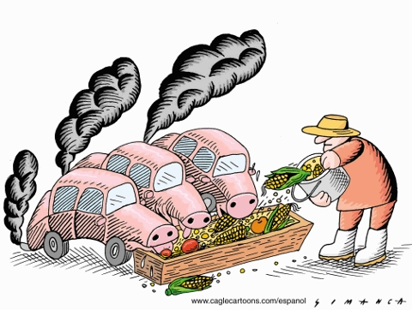

**source: http://dangerousintersection.org/wp-content/uploads/2008/04/corn-ethanol.jpg**

Production of Fuel Ethanol from Corn

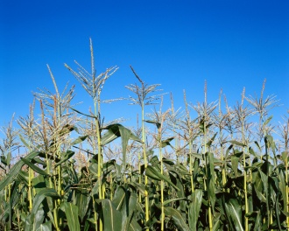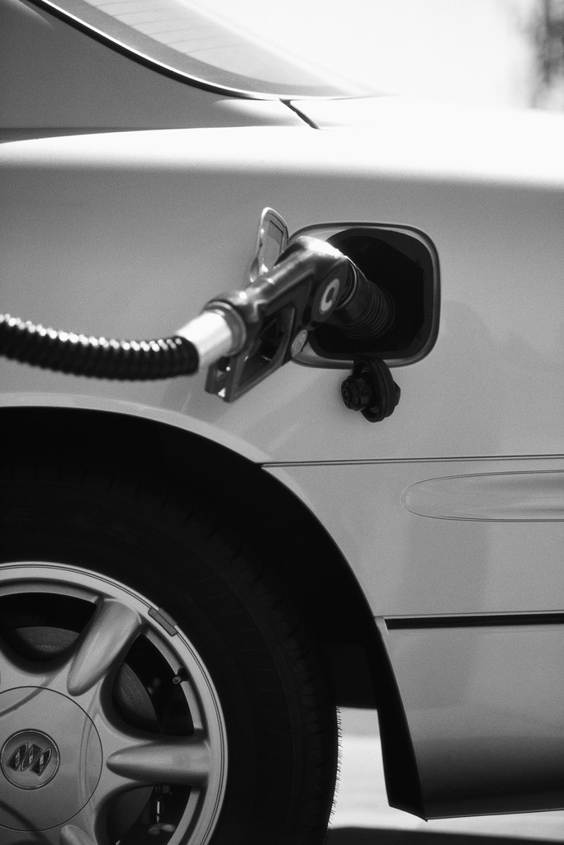

**Background**

The increasing demand for liquid fuels for transportation, increased world-demand for oil (gasoline), and the negative consequences of global warming have all contributed to the increased use of corn-based sugar to produce ethanol. Ethanol can be used as a substitute for gasoline to be burned in many of today’s passenger cars and trucks. Most gas stations currently use 10% ethanol in their gasoline. However, it has also been used as 85% ethanol to 15% gasoline at some gas pumps called E85 or Flex fuel. Running this fuel in the gasoline motor typically does not require any mechanical modification. **Not all gasoline motors are manufactured to run on E85 so it is best to check your car’s owners manual before fueling up with E85**.

Corn that is used in this laboratory experiment was grown at the LISD Center for a Sustainable Future on Tipton Highway. Several varieties of corn were grown to evaluate their potential use as a fuel ethanol source. We may evaluate several varieties as a class to find out which crop produces the most ethanol per dry weight of corn.

*Fermentation:*

Fermentation (as it is used in this lab) is the process that converts the simple sugars produced by the corn kernel (reactants) and converts the sugar to fuel ethanol and carbon dioxide (CO2) (products) under anaerobic conditions (without oxygen). Added enzymes and enzymes from particular strains of yeast (catalyst) combined with the absence of oxygen are key ingredients for the breakdown of sugar and the simultaneous production of ethanol and carbon dioxide (CO2).

alpha amylase

Glucoamylase

Yeast

Corn Starch (complex sugar) Dextrin Fermentable Sugar Ethanol + CO2

*Distillation*

Distillation is a process used in chemistry to separate two liquid substances. For example, gasoline is a mixture of many different hydrocarbons like octane, benzene, toluene, etc. A form of distillation is used to separate the different components of gasoline into these individual components. The physical property used to separate these different compounds is **boiling point**. The boiling point is the point at which the substance transitions from the liquid state to the gaseous state.

*Advantages and Disadvantages of Using Corn-based Ethanol*

|  |  |
| --- | --- |
| **Advantages** | **Arguments against Corn-based Ethanol** |
| * New product for agricultural | * Takes a significant amount of water and energy to produce |
| * Reduce dependency on foreign oil | * Use of corn as a fuel conflicts with its use as a food source |
| * Helps produce “green” jobs in the US | * Uses almost as much oil to produce ethanol as it saves. |
| * Partly helps reduce global warming gases   (http://www1.eere.energy.gov/vehiclesandfuels/pdfs/program/ethanol_brochure_color.pdf) | * Currently, depends on government subsidies |

**Vocabulary**

|  |  |
| --- | --- |
| **Brix:** | is an indirect measurement of the amount of sugar available to the yeast during fermentation |
| **Alpha amylase:** | Enzyme that is responsible for breaking down complex plant starches into smaller sugar molecules called dextrins |
| **Glucoamylase** | Enzyme responsible for converting dextrin to fermentable sugars for yeast metabolism |
| **Dextrin** | short chain polymer of glucose |
| **Starch** | Long-chain sugar molecule produced as a result of photosynthesis and used as a storage molecule by plants |
| **Fermentable sugar** | Simple sugars such as glucose and fructose that can be converted into ethanol by fermentation with yeast. |
| **Fermentation** | transformation of organic (sugar) compounds by microorganisms. It is usually accompanied by the evaluation of gas as the fermentation of glucose into ethanol and carbon dioxide (CO2) |
| **Milling** | Process used in a fuel ethanol plant to physically break a starch containing material into a fine powder, which will be use in fermentation |
| **Corn Meal** | In corn ethanol production, the result of the milling process |
| **Corn Mash** | Milled grain and water. Term can be used describe material in liquefaction and fermentation tanks. |
| **Slurry** | Moment when corn, water, and alpha amylase are combined at the beginning of the corn ethanol production process |
| **Liquifaction** | Name of the step in ethanol production when slurry or corn mash is made. |
| **Beer Well** | holding tank for the fermented corn, but before it enters the distillation process |
| **Distillation** | Process of separating the ethanol from the waste products of fermentation (exa. yeast, water, left over grain, etc) |
| **DDG (dried distillers grain)** | Parts of the corn mash that did NOT get fermented and turned into ethanol. This material is dried and made into animal feed. |
| **Ethanol (EtOH)** | Final product of fermentation (200 proof or 100% EtOH). This product can be blended with gasoline. |
| **HPLC (High Pressure Liquid Chromatography)** | Used in analytical chemistry to evaluate the concentration of ethanol, methanol, glucose, and many other chemicals found in corn mash. |

Holding area for fermentation products until distillation can occur.

Process of separating the EtOH from the water and grain left after fermentation.

Yeast “eat” corn under anaerobic conditions to produce EtOH. Glucoamylase is the important enzyme because it converts dextrin to simple sugars like glucose and maltose, which are easily used by the yeast.

Enzymatic process of converting complex starch into smaller sugar, dextrin.

Process that uses a hammer mill to grind corn kernels into flour

CO2: used as a beverage gas and to make dry ice.

DDG (Dried Distillers Grains): used as animal feed.

Ethanol (EtOH): blended with gasoline for fuel.

**Distillation**

**Beer**

**Well**

**Fermentation**

Yeast

Nutrients

Yeast

Gluco-

amylase

Antibiotics

Alpha Amylase

Hot Water

185oF

**Liquifaction**

Corn Mash

“Slurry”

Corn Meal

**Milling**

Corn from field

**Overview of Commercial Fuel Ethanol Production from Corn Importance of proper pH and temperature for alpha amylase**

**Corn Ethanol Statistics**

* Corn Kernel = 70% starch
* 1 bushel of corn = 56 lbs
* 1 bushel = 2.6 – 2.7 gallons of ethanol
* The 2008 season national average corn yield was 153.8 bushels per acre
* **One average, 415 gallons of ethanol produced per acre of corn**



Enzymes that can be purchased for this lab:

Sigma-Aldrich, α-Amylase from Aspergillus oryzae, Cat # A8220-50ML

Sigma-Aldrich, Amyloglucosidase from Aspergillus niger, Cat # A7095-50ML

 **Objective for this Project:**

You are all research scientists working to develop a protocol or “recipe” to make the most ethanol possible in your fermentations with the fewest contaminants. I am a private company looking to start an ethanol plant and I need a formula that will work! I will reward the winning group with a contract to build a full scale production plant with your formulation making your company millions of dollars! The stakes are high! Can your team do it?

You will work together in lab groups to develop a fermentation formula that will produce the highest concentration of ethanol from corn. Below are some variables that you can work with to maximize your ethanol production:

**Yeast**: There are different types or brands of yeast that you can use in your fermentation. I will supply you with yeast, but if you go to the grocery store and find another brand of yeast that you would like to try, you may do so. Also, you can try increasing the amount of yeast you add or even decreasing the amount. It is up to you!

**Urea**: As yeast grow and multiply they need a lot of nitrogen in order to keep growing and producing ethanol. You might help the yeast grow by adding more urea? Be careful, too much urea can become toxic to the yeast.

**Type of Corn Used**: It is possible that there is a species of corn that the Agricultural Technology program grew at the Ag Learning Center that is a better type for producing more starch…..therefore more ethanol? They grow multiple varieties and they grew a few just for their ability to produce more ethanol.

**Be creative!! I**f your group thinks that **temperature or pH** might make more ethanol, you can experiment with that process too!

**Requirements for the notebook:**

You do NOT have to put procedures in your notebook. I will be looking for the following:

* Title
* Introduction
* Purpose/objective statement
* Hypothesis
* Results and Conclusions. I will be picky on how complete you write your results/conclusions!
  + See student data sheet for help in writing your results and conclusions.

**SLOPs used in this Lab Activity**

**Standard Laboratory Operating Procedures (SLOPs) for Ethanol Activity:**

Sample Analysis:

When taking a sample from your fermentation, analyze your sample in the following order:

* + pH
  + Brix
  + HPLC
  + Yeast Health - Counts

*pH Analysis*

1. You may use the pH meter for more accurate measurement of pH. The teacher will show you how to operate the pH meter.

*Brix Analysis*

1. As you prepare your sample for HPLC analysis (see SLOP for HPLC), you will need to take one drop of filtered fermentation mixture (mash) and place it on the refractometer.
2. Place the window over your sample as described below
3. Read your result, in %
4. Clean your sample off the refractometer for next use with a KimWipe

*HPLC Analysis*

1. Assemble a 10 mL syringe, funnel, filter paper, and 0.45 um syringe filter as shown in photo
2. Add 30 mL of fermentation mixture to funnel and allow 5-10 minutes for filtrate to come out of the bottom of the funnel.
3. While filtrate is coming out of the bottom of the funnel, you can perform Brix test (see Brix test SLOP)
4. When ~3 mL of filtrate is visible in the barrel of the syringe, use plunger to filter the sample further and 1.0 – 1.5 mL of filtrate into HPLC sample vial. If HPLC vial is not available you can use a 1.5mL microcentrifuge tube.
5. Put cap on vial and BE SURE TO LABEL PROPERLY! Make sure label is easy to read!
6. Label vial as follows:
   1. Name of Team Leader
   2. Date
   3. Time = _____ (Exa. T=0hrs, T=24hrs, etc.)

**Evaluating Yeast Health**

Yeast Health is an important factor in how much sugar is converted to ethanol. The healthier the yeast, the more likely the yeast will convert the sugar to ethanol. Yeast is a single-celled fungus that has a thick cell wall surrounding the cell. A healthy yeast cell has a healthy cell wall and does a good job of keeping unwanted chemicals out of its cell. A weak, dead, or dying cell will have a cell wall that will “leak”. We will identify dead and dying cells by the weakness in this cell wall. You will make a wet mount of the yeast cells stained with methylene blue. **If the internal cytoplasm of the cell is stained blue that it means that cell is dead or dying. If only the cell wall is stained then it is healthy and most likely producing ethanol from the fermentable sugar.**

See pictures below:

Healthy Yeast

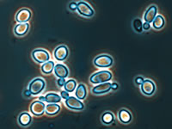

Dead or Dying Yeast

<http://www.etslabs.com/images/ContentImages/Yeast.jpg>

SLOP:

*Yeast Health Evaluation SLOP:*

1. Weigh a 250 mL Erlenmeyer flask and tare or “0” your balance.
2. Using a transfer pipette, remove 10 g of fermentation mash using a large transfer pipette and transfer to tarred 250 mL flask. Hint: use scissors to cut tip off the end of the transfer pipet in order to suck up the proper amount of corn mash
3. Add distilled water until you maintain level of 200 mL. You can use graduation marks on Erlenmeyer flask.
4. Swirl to mix and add 3 drops of methylene blue solution. Swirl to mix again.
5. Use micropipette to add 25µL of yeast suspension/methylene blue to hemocytometer. Ask teacher for help and demonstration if you are unsure of this step.
6. Count the numbers of **live** cells in each of the areas of the slide described below.

**Standard Laboratory Operating Procedure for Ethanol Production:**

*Note: The following procedure works fine, but it may not produce the highest ethanol concentration.*

**Day 1 of Experiment: Enzyme Treatment of Corn 🡪 Liquifaction**

1. Add 350mL of de-ionized water into a 500mL Erlenmeyer flask and heat to 195oF (90.6oC).
2. Slowly add the hot water from step 1 to another flask containing 100 g of corn flour and place it to on a stirring hot plate with constant stirring. It is now called corn mash and this is the liquefaction step.
3. Add 100 µL of GC-358 **alpha amylase** enzyme if temperature of corn mash is between 75 – 85 oC
4. Continue to stir for 15 minutes and adjust temperature to 83.3C – 85oC during this time. **The temperature is very important**! Your experiment won’t work without maintaining a temperature of 83.3 – 85oC!
5. Continue stirring the corn mash for the rest of the class period while maintaining a temperature between 83.3 – 85oC. After the class period, your flask will be removed from the heat and allowed it to cool to room temperature until the next day.
6. The figure below illustrates how you should set up your liquefaction

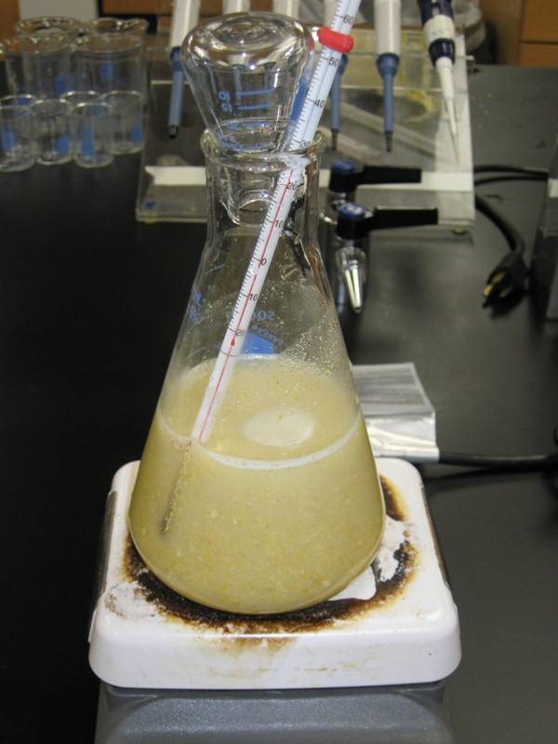

Thermometer wedged with the end situated half way to the bottom of the flask. Do not put thermometer right on the bottom of the flask.

500 mL Erlenmeyer flask with 350 mL of corn mash

25 mL Erlenmeyer flask

**Day 2 of Experiment: Fermentation of Corn**

1. Before getting ready to do your fermentation, take a small sample (25mL) to measure pH, brix, and sample for HPLC (see SLOPs for each of these measurements). This is your time=0 sample collection. You will also collect one sample for pH, brix, HPLC, CO2, and yeast health at time=24hrs and time=72hrs.
2. In a separate 250 mL Erlenmeyer flask, use a transfer pipette and transfer 10 g of corn mash solution into the flask. See SLOP for Yeast Health.
3. 1 mL of 0.5% (w/v) ampicillin was added to your fermentation to minimize bacterial contamination of your corn mash. This step was done for you.
4. Add 200 mg of Urea (Nitrogen source)
5. Add 100 µL of yeast nutrient
6. Add 2 g of dry yeast. You can change the amount or type of yeast you add here (*Saccharomyces cerevisiae*)
7. Add 0.5 mL of G-zyme 480 (**Glucoamylase**) (10% solution)
8. You shouldn’t need to adjust the pH of the fermentation, but in case you need to adjust to 5.0 – 5.5 you can do so with 1M HCl or 1M NaOH using a pH meter.
9. Ferment for 72 hours at room temperature. Note: it may be necessary to ferment at 92oF (33oC) in a water bath. This is a variable that you may change if you want to. Make sure to note the change in your notebook.
10. Make sure fermentation is set up as in Figure 1.
11. Record all data and observations in your notebook!

Your fermentation should be set up as described below. Make sure to fill your air lock half way with distilled water.

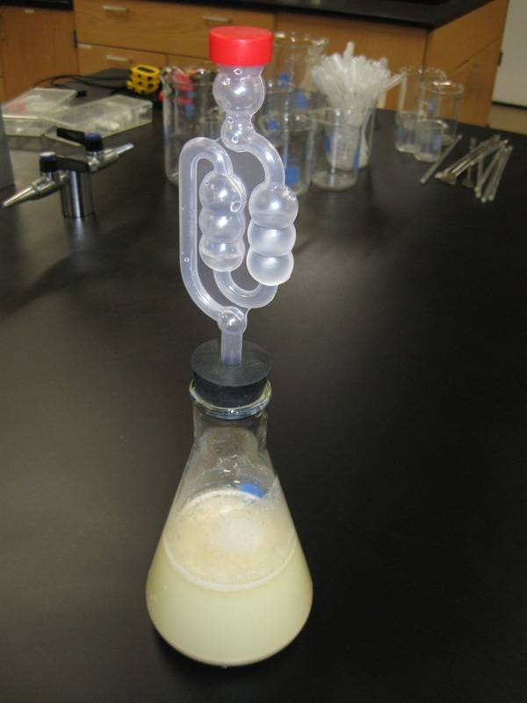

500 mL Erlenmeyer flask with corn mash that has been treated with enzymes.

Air lock filled half way with water

Suggestions for collecting and processing your sample:

* Collect 25 mL of mash from your fermentation in a small beaker (50-mL). You can just use the graduation marks on the side of the beaker because it doesn’t need to be exact.
* Collect 10 g of mash for yeast cell count in a 250 mL E flask using a transfer pipette.
* Use sample from step 1 to measure pH
* Use sample from step 1 to measure Brix, and fill syringe for HPLC analysis.

Schedule of Events:

Day 1:

* Pre-lab discussion on Corn Ethanol Lab
* Discuss fermentation and lab procedures
* Practice staining and counting yeast cells, reading brix, and getting familiar with the HPLC

Day 2:

* Answer any questions about Corn Ethanol Lab
* Group discussion on how to set up fermentations for maximum ethanol output
* Set up liquefaction step of corn ethanol lab
* More practice on staining and counting yeast cells, reading brix, and getting familiar with HPLC

Day 3:

* Set up Fermentation
* Collect t=0 hrs sample and measure Brix, pH, HPLC, and Yeast Health (counts)
* Pre-lab discussion of distillation

Day 4:

* Collect t=24 hr sample and measure Brix, pH, HPLC, and Yeast Health (counts)
* Guest Speaker: Jen Loar, Global Ethanol

Day 5:

* Discussion of distillation
* Distillation of methanol using fractional distillation.

Day 6:

* Group “Mind Map” of the corn ethanol process using Smartboard
* Group concept review of terms using Interwrite remotes
* Collect t=72 hrs sample and measure Brix, pH, HPLC, and Yeast Health (counts)
* Begin data analysis
  + Make graphs of the following data vs time.
  + Brix
  + Ethanol
  + Yeast Health
  + Does your data validate or invalidate your hypothesis?

Name: _________________________________________ Date: __________

**Ethanol Lab Questions**

1. What is the process that converts corn starch sugar to ethanol and carbon dioxide?
2. On average, how much ethanol is produced per acre of corn in the United States?
3. What is the name of the process that separates ethanol from the water and grain at the end of fermentation?
4. What is the name of the process that converts corn starch to dextrin sugar?
5. Explain why we need to use enzymes (alpha amylase and glucoamylase) to help in the corn ethanol fermentation.
6. Explain why distillation is used to separate ethanol from the other parts of the fermentation reaction? Why can’t you just filter out the ethanol?
7. Analyze the following statement and rewrite it so that it is correct: **Ethanol can be mixed with diesel fuel at a percentage of 20% for today’s cars.**
8. Construct your own diagram of the overall corn ethanol process using the terms: **Corn, milling, Fermentation, liquefaction, Distillation, CO2, ethanol, yeast, DDG**.
9. Based on what you now know about making corn ethanol, invent or develop a process of producing ethanol that makes more gallons per acre. (Hint: cellulosic ethanol)
10. In your opinion, do you think it is a good idea to make ethanol from corn? In your answer, make sure you state reasons why or why not? Use the websites: [www.doe.gov](http://www.doe.gov) and renewable fuels association (http://www.ethanolrfa.org/).

Student Data Sheet

Name of Sample: ___________________________________________

Put this table in the results section of your lab notebook

|  |  |  |  |  |  |  |  |  |  |  |
| --- | --- | --- | --- | --- | --- | --- | --- | --- | --- | --- |
| Date/Time | Brix | pH | DP4+ | DP3 | Glucose | Lactic Acid | Glycerol | Acetic Acid | Ethanol | Live Cells |
|  |  |  |  |  |  |  |  |  |  |  |
|  |  |  |  |  |  |  |  |  |  |  |
|  |  |  |  |  |  |  |  |  |  |  |

Total Ethanol Production from Fermentation (T=72 hrs): ________ %

**Should be included in your notebook:**

Was your hypothesis correct and why?

What were some problems that you had during your experiment?

What are some are a couple of things you would do differently next time you run this experiment to improve ethanol production?

**Prepare charts in MS Excel, which will go in your results section of your lab notebook:**

1. Time vs Live cell counts
2. Time vs Glucose and Ethanol
3. Time vs Brix

