March 2022

Outlining an Integrated Pipeline from Biomass to Bioproduct

The analysis identifies key strategies to improve biorefinery efficiency and economic feasibility.

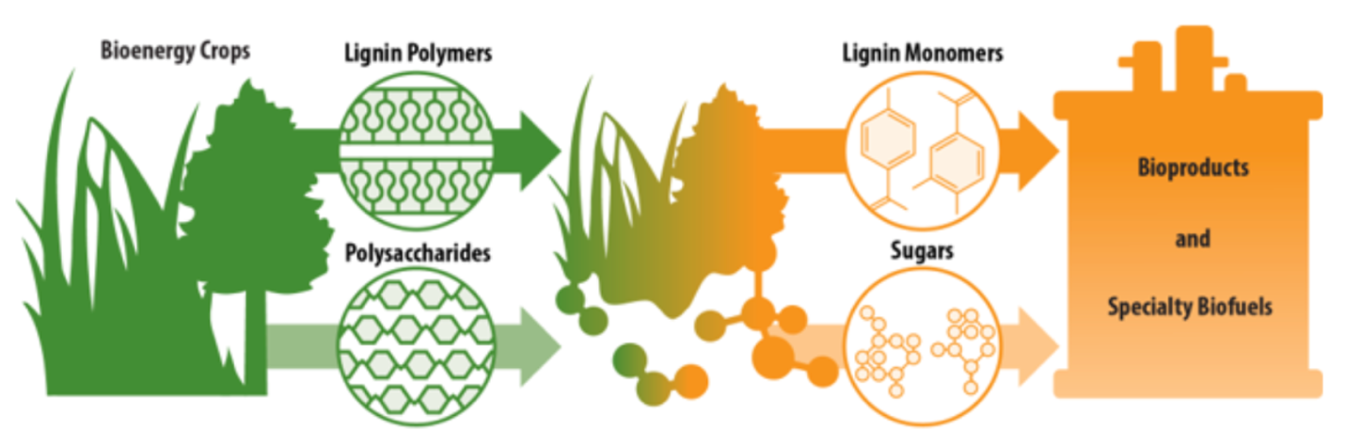Research at the Great Lakes Bioenergy Research Center spans the processes needed to break down plant biomass into lignin and sugar streams and use them to produce chemicals and advanced biofuels, enabling the integration of a full pipeline from lignin to a target bioproduct.

The Science
The efficient and economic production of plant-based fuels and chemicals requires using as much of the plant biomass as possible. At a biorefinery, once plant sugars are extracted to ferment into biofuels, the bulk of the remaining biomass is composed of the complex polymer lignin. Lignin is typically burned for energy, but considerable research efforts are underway to develop high-value bioproducts from lignin to improve the overall economics of the biorefinery.
A new study from the Great Lakes Bioenergy Research Center (GLBRC), based at the University of Wisconsin–Madison, describes a complete lignin-to-bioproduct pipeline that could produce high yields of a target chemical, 2-pyrone-4,6-dicarboxylic acid (PDC), with high potential value as a platform chemical to make adhesives, plastics, and other biopolymers. The process integrates biomass deconstruction using the solvent gamma-valerolactone (GVL), lignin depolymerization using hydrogenolysis, and microbial conversion of the resulting aromatic monomers to PDC using an engineered strain of the bacterium Novosphingobium aromaticivorans.

The Impact
The study shows the feasibility of integrating multiple processes developed by GLBRC into a pipeline to generate valuable products from biomass lignin as well as carbohydrates. The analysis identifies key factors that impact the technical and economic considerations of producing lignin-derived bioproducts in a biorefinery, highlighting areas where strategic improvements could increase productivity or reduce the minimum selling price of a lignin-derived product.

Summary
Ongoing research at the Great Lakes Bioenergy Research Center is working to improve each step of the process needed to turn bioenergy crops into valuable plant-based fuels and chemicals, including its pioneering use of GVL as an approach to deconstruct plant biomass and produce separate streams of lignin and carbohydrates. The current study integrates the Center’s multidisciplinary expertise to evaluate the technical and economic feasibility of a complete lignin-to-PDC pipeline.
Lignin is a complex polymer that can yield different combinations of its component monomers depending on how it is broken down. Using GVL-derived lignin from four different types of biomass—poplar, maple, switchgrass, and energy sorghum—the researchers found that reductive catalytic fractionation could produce a range of different monomers, some of which could be efficiently converted to PDC by N. aromaticivorans. They selected catalytic conditions that maximize production of the monomers that the microbe can efficiently funnel into PDC and showed that the pipeline can work with a variety of bioenergy feedstocks. The modeled pipeline is also energetically self-sufficient, generating enough heat and electricity for its own operation by burning the fraction of lignin that is not recovered as monomers.
The researchers then conducted a technoeconomic analysis of the full pipeline to identify key steps in the process that affect the minimum selling price of PDC that would allow a biorefinery to break even. The cost of lignin was identified as an important contributor to the overall process cost, suggesting that improving biomass deconstruction and maximizing yield of aromatic monomers from lignin would have a large impact on the economics of the biorefinery. In addition, improvements in catalytic and microbial processes could help reduce reactor size and thus the capital cost associated with these steps. This lignin-to-bioproduct pipeline provides a baseline from which improvements to an integrated biorefinery can be compared.

Contact
Daniel Noguera
Great Lakes Bioenergy Research Center, Wisconsin Energy Institute, and Department of Civil and Environmental Engineering, University of Wisconsin–Madison
dnoguera@wisc.edu, (608) 263-7783

Funding
This work was supported by the U.S. Department of Energy (DOE) Great Lakes Bioenergy Research Center (DOE Office of Science BER grant no. DE-SC0018409). Additional funding from the Chilean National Commission for Scientific and Technological Research (CONICYT) as a fellowship to Jose M. Perez is also acknowledged.

Publication
J. M. Perez, et al. Integrating lignin depolymerization with microbial funneling processes using agronomically relevant feedstocks. Green Chemistry, Advance Article March 10 (2022). [DOI: 10.1039/D1GC03592D]
Related Links
https://www.glbrc.org/
https://pubs.rsc.org/en/content/articlelanding/2022/GC/D1GC03592D

