AUGUST 2023

Switchgrass roots push the brakes on plant growth

Study reveals that photosynthesis declines in bioenergy switchgrass are triggered by a buildup of carbohydrates in its roots and rhizomes in preparation for overwintering.
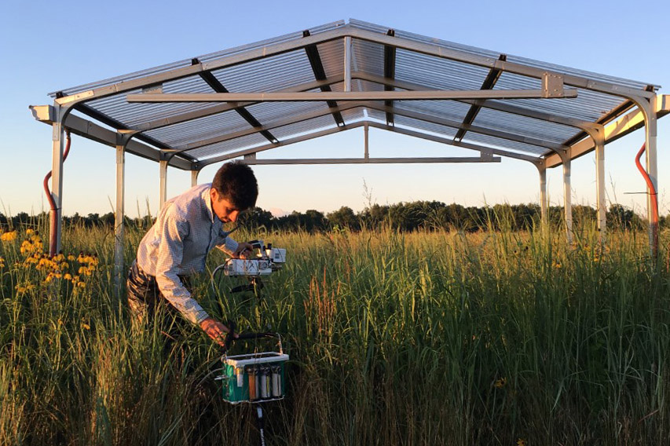
Photo Credit: Mauricio Tejera-Nieves

Researcher Mauricio Tejera-Nieves studies how carbon shifts in plant tissues, like bioenergy switchgrass, in response to abiotic stresses.

The Science

Plants photosynthesize to convert sunlight, carbon dioxide (CO2), and water into the carbohydrates they use to grow and store energy. Many of the perennial grasses that are used for biofuel production decrease photosynthesis in the middle of summer. When these plants slow photosynthesis, they limit the amount of biomass they can produce. In this study, scientists discovered that the photosynthetic decline in the bioenergy crop switchgrass was triggered by the buildup of carbohydrates in the plant’s rhizomes, the specialized roots that serve as food storage over winter.

The Impact

Crops like switchgrass can be used to make fuel and chemicals traditionally produced by fossil fuels. Transitioning to renewables like plant-based fuels and chemicals are a key component to slowing climate change. Understanding why switchgrass might be limiting its photosynthesis can allow scientists to find strategies to create plants that can grow as big as possible, increasing the amount of biomass available for biofuels. This research shows a potential growth limitation in bioenergy switchgrass, informing future research into how to create plants with more biomass and greater biofuel yields.

Summary

To understand what is driving the seasonal decline in leaf photosynthesis in switchgrass, scientists at the Great Lakes Bioenergy Research Center measured the photosynthetic rates and carbohydrate amounts of leaves and roots in switchgrass plants under rain exclusion shelters and those under ambient rainfall in Michigan.

Plants that received less rain had lower photosynthetic rates than rainfed plants, yet rainfed plants still slowed photosynthesis late in the season, suggesting that water availability wasn’t the only reason for the decline. The carbohydrates in the plant’s rhizomes increased four-fold with the increase of photosynthetic rates and stabilized when photosynthesis reached constant low values, suggesting that the rhizomes serve as a carbohydrate sink that limits leaf photosynthesis during the growing season.

This work reveals that switchgrass limits its own growth by slowing photosynthesis when its rhizome reserves are full, presenting opportunities to investigate the genetics and molecular machinery of this relationship to engineer and breed plants that can overcome this limitation and reach their full biomass potential.

Contact

Mauricio Tejera-Nieves
Michigan State University
mauri@msu.edu

Berkley Walker
Michigan State University
berkley@msu.edu

Funding

This work was supported by the Great Lakes Bioenergy Research Center, U.S. Department of Energy, Office of Science, Office of Biological and Environmental Research under Award Number DE-SC0018409, by the National Science Foundation Long-term Ecological Research Program (DEB 1832042) at the Kellogg Biological Station, and by Michigan State University AgBioResearch.

Publications

Tejera-Nieves M, et al. Seasonal decline in leaf photosynthesis in perennial switchgrass explained by sink limitations and water deficit. Frontiers in Plant Science 13, 1023571 (2023). [DOI: 10.3389/fpls.2022.1023571]

