August 2023
Studies provide clues to how some bacteria shed fat
Researchers identify gene regulator, protein responsible for bacterial lipid secretion
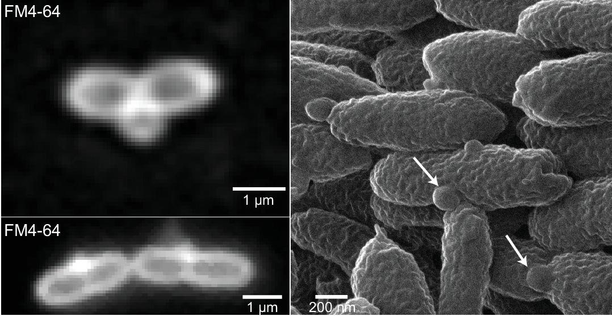
Image courtesy of Alice Dohnalkova
Fluorescence images of ΔdalA cells stained with FM4-64 (left). Collaborators with the Pacific Northwest National Laboratory produced a helium-ion microscopy image of the same strain (right) showing outer membrane protrusions (white arrows). Watch a video of
The Science
The cell envelope plays an important role in the life cycle of bacteria, controlling its shape and creating a physical barrier to protect it from the environment. Bacteria must manage cell growth and division to survive and reproduce. Disrupting that process leads to release of fatty acids, or lipids. Two new studies shed light on the process in one, and likely other, species. One study identifies a previously unknown protein responsible for cell envelope integrity. The other reports on a system that regulates envelope functions that can be altered to increase lipid production.
The Impact
Lipids and oils produced by microbes could provide a source of renewable alternatives to petroleum-derived compounds, such as lubricants and jet fuel. Some microbes produce lipids naturally, but many only do so when starved of nutrients like nitrogen. One approach to increase their production is to genetically rewire the circuits that limit lipid production. In 2017, scientists found two such mutant strains that produced high levels of lipids by squeezing them out of their cell envelope, making the oil easier to harvest. These new studies help explain the mechanisms these bacteria use to shed their fat and reveal new ways to increase lipid secretion.
Summary
Scientists with the Great Lakes Bioenergy Research Center analyzed two mutants of the Gram-negative bacterium Rhodobacter sphaeroides that secrete lipids.
One study identifies a two-component regulatory system called CenKR, which controls the genes involved in maintaining the integrity of the cell envelope. They found that increasing the CenKR activity caused cells to become longer and stick together because of loosening of the mesh-like structure that forms the cell wall, which were revealed with a cryo-electron microscope and three-dimensional imaging techniques.
The other study identified a previously uncharacterized envelope protein controlled by the CenKR regulator. They propose that this protein, called DalA (for Division Associated Lipoprotein A), serves as a scaffold that allows other enzymes to build the mesh that is needed for cell division and envelope integrity. In addition, they used high-resolution cell imaging to show that a DalA mutant secretes materials from the cell division site.
Contact
Timothy Donohue
University of Wisconsin–Madison
tdonohue@bact.wisc.edu
Funding
This work was supported by:
- U.S. Department of Energy, Office of Science, Office of Biological and Environmental Research
- NIH Common Fund Transformative High Resolution Cryo-Electron Microscopy program
- National Science Foundation Graduate Research Fellowship Program
- National Institute of Health Genetics Predoctoral Training Program
- National Institute of Health NRSA Postdoctoral Fellowship
- Foster Wisconsin Idea Fellowship, UW– Madison, Department of Bacteriology
A part of this research was performed at EMSL, a DOE User Facility sponsored by the Office of Science’s Biological and Environmental Research, located at Pacific Northwest National Laboratory.
Publications
Alberge, François, et al. A previously uncharacterized divisome-associated lipoprotein, DalA, is needed for normal cell division in Rhodobacterales. MBio, e0120323 (2023). [DOI:10.1128/mbio.01203-23]
Lakey, Bryan D., et al. The role of CenKR in the coordination of Rhodobacter sphaeroides cell elongation and division. MBio, e0063123 (2023). [DOI:10.1128/mbio.00631-23]
Lemmer, Kimberly C., et al. Mutations That Alter the Bacterial Cell Envelope Increase Lipid Production. MBio, 8, 10.1128/mbio.00513-17 (2017). [DOI:10.1128/mbio.00513-17]
Related Links
Modifying Cell Wall Can Increase Bacterial Lipids, glbrc.org

