**February 2025**

**NEEDLE points to gene regulators**

**User-friendly platform predicts which proteins trigger gene expression, enabling scientists to engineer more productive and hardy crops**

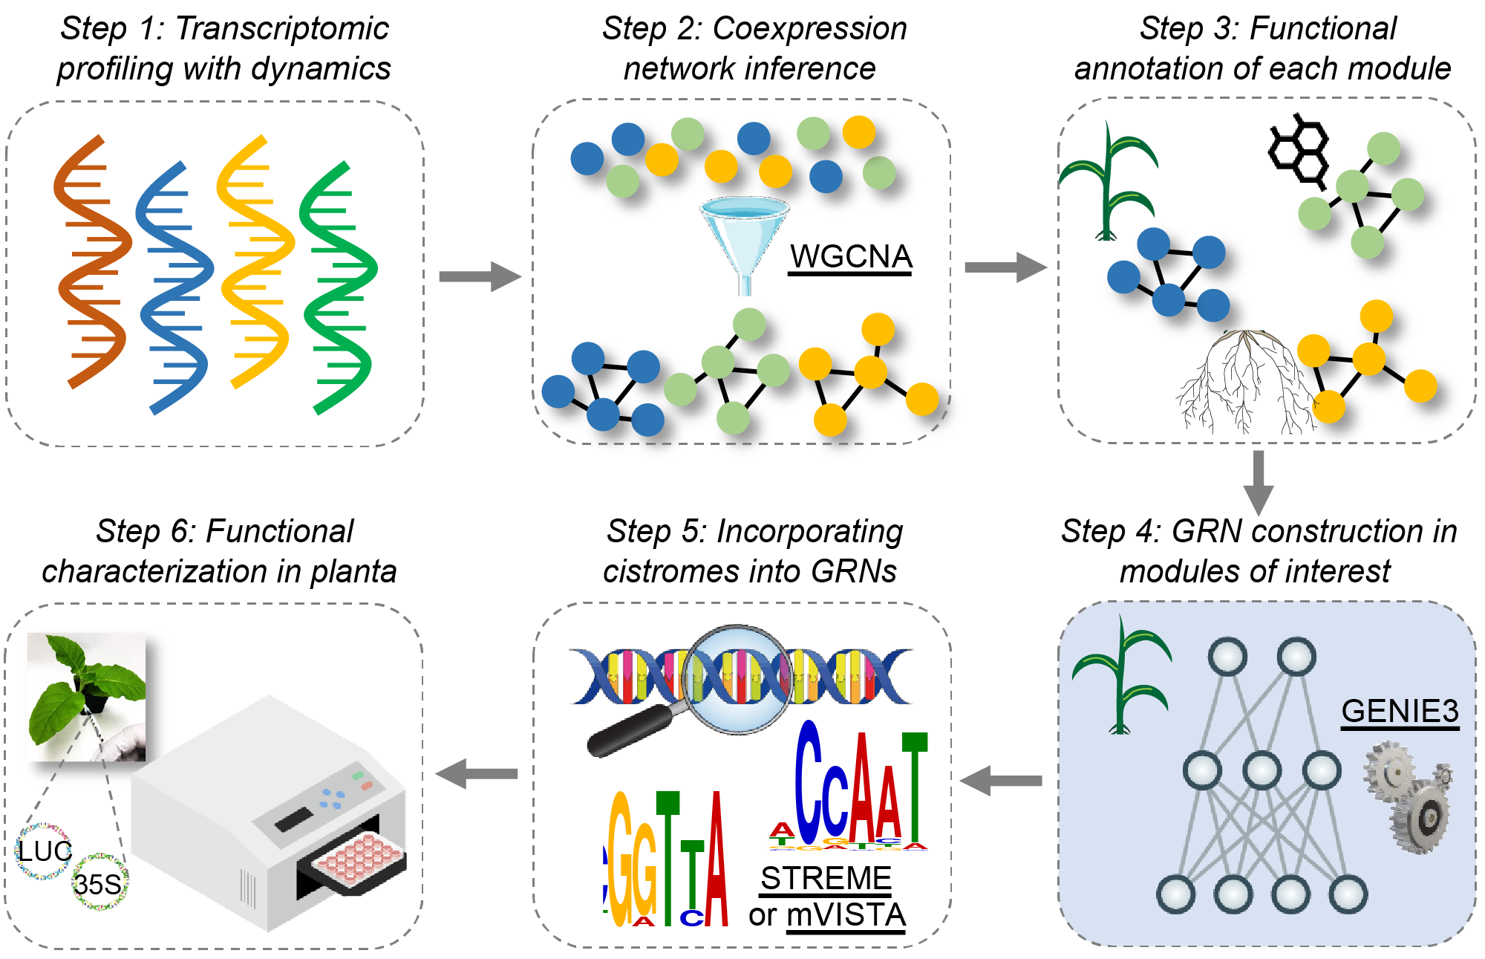

Image courtesy of authors

Schematic of NEEDLE, a user-friendly platform for predicting the proteins that trigger genes to synthesize products in plant cells.

**The Science**

Transcription factors are proteins that bind to DNA inside a cell, activating or blocking the expression of a particular gene. Accurately predicting these gene regulators is a key step to making more productive and stress-resistant crops. But the complex interactions between DNA, RNA, and proteins within cells make this difficult, and scientists lack comprehensive datasets for most crop species. Therefore, scientists with the Great Lakes Bioenergy Research Center developed a user-friendly pipeline to identify the transcription factors that regulate target genes associated with important traits.

**The Impact**

Meeting the energy and food demands of the growing world population requires the rapid development of crops that can withstand the stresses associated with climate change and produce higher yields. Accurate prediction of transcription factors allows scientists to reprogram genes that control traits such as growth, development, and stress resilience. This approach will allow scientists to uncover genes involved in complex biological processes such as metabolism, stress response, and interactions between plants and microbes.

**Summary**

GLBRC scientists designed NEEDLE, a platform that systematically generates co-expression gene network modules, measures gene connectivity, and establishes network hierarchy to pinpoint key transcriptional regulators from dynamic transcriptome datasets.

Researchers tested it on both known and unknown questions in order to determine its accuracy and usefulness in identifying transcription factors of target genes. NEEDLE identified transcription factors regulating the expression of the crucial cell wall biosynthetic gene *Cellulose Synthase-Like F6* (*CSLF6*) in Brachypodium and sorghum and validated their predicted regulatory function. The analyses not only uncovered novel regulators of *CSLF6* but revealed both functional divergence and conservation of transcription factors across species through cross-species prediction and validation or divergence of gene regulatory elements among grass species.

**Contact**

Federica Brandizzi

Michigan State University

fb@msu.edu

**Funding**

This study was supported primarily by the Great Lakes Bioenergy Research Center, U.S. Department of Energy, Office of Science, Office of Biological and Environmental Research with contributing support from National Institutes of Health Chemical Sciences, Geoscience and Biosciences Division; DOE Office of Basic Energy Sciences; and MSU AgBioResearch.

**Publications**

Ko, D. K., & Brandizzi, F. A network-enabled pipeline for gene discovery and validation in non-model plant species. *Cell Reports Methods*, **5** (2025). [DOI:[10.1016/j.crmeth.2024.100963](https://doi.org/10.1016/j.crmeth.2024.100963)]