November 2022

Engineered Poplar Lignin Has More of Valuable “Clip-off” Chemical

Scientists have introduced a bacterial enzyme into bioenergy poplars to increase the amount of a valuable platform chemical.

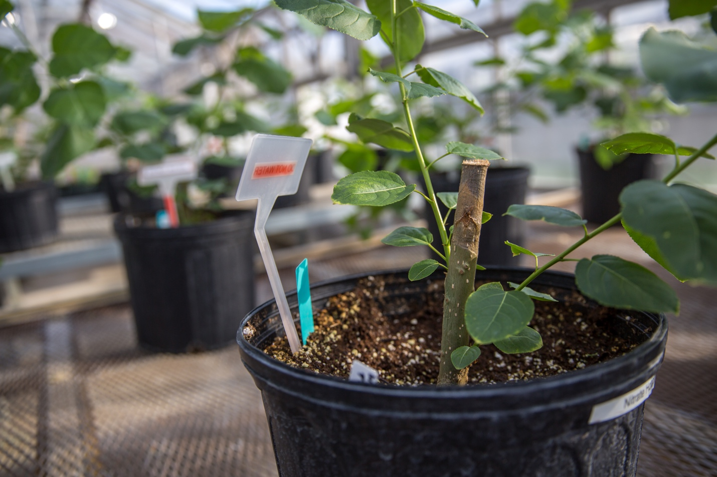

[Image credit]
Image courtesy of Chelsea Mamott/Great Lakes Bioenergy Research Center

[Image caption]
Rows of potted poplar trees grow in a research greenhouse at Michigan State University. Engineering bioenergy crops, like these poplar trees, can produce biomass with lignin that is more valuable and/or easier to break down.

The Science
Lignin is the complex polymer that gives plants their structural integrity also makes them difficult to break down. This complexity also affords opportunities to make a diverse array of biochemicals and bioproducts from components in lignin. Building blocks that are present in small amounts in the lignin of the bioenergy crop poplar are valuable platform chemicals that are easy to “clip-off” during plant deconstruction. Scientists at the Great Lakes Bioenergy Research Center engineered a new type of poplar with more of this valuable chemical and less lignin overall, resulting in wood that is easier to deconstruct and more valuable.

The Impact
Lignin is difficult to break down and chemically complex. Although those attributes are a major challenge for industrial biomass processing, they also open the door for creating important and valuable biochemicals and bioproducts from lignin. This research demonstrates a new way tof engineer the lignin in bioenergy crops that makes it easier to break down. This new method also changes the composition of lignin so that it includes more of a valuable building block that can be upgraded to valuable biochemicals and bioproducts. These changes could make the production of biofuels and bioproducts easier and cheaper.

Summary
The plasticity of lignin synthesis allows scientists to engineer lignin polymers that have added value and are easier to break down. Up to 10% of poplar lignin is naturally comprised of p-hydroxybenzoate (pHB). This group is attached to the lignin polymer by weak ester linkages (relative to ether linkages that abound in lignin), making it easy to “clip-off” in biomass deconstruction. Once pHB is separated from biomass, it is both a valuable platform chemical and can be upgraded to other biochemicals and bioproducts. The pathway by which pHB is synthesized in plants has not been fully elucidated. However, by expressing bacterial chorismite pyruvate lyase (CPL) in plastids, plants have been shown to produce more pHB. In this study, GLBRC scientists produced transgenic hybrid poplar lines to express bacterial CPL, which resulted in a 50% increase of stable pHB in mature trees and 10 times more in developing trees compared to control trees. This work demonstrates how engineering bioenergy crops can improve the efficiency and value of industrial biomass deconstruction by increasing the amount of easily cleavable and valuable chemical groups.

Contact
Shawn D. Mansfield
Professor of Wood Science, University of British Columbia
shawn.mansfield@ubc.ca, 604-822-0196

Funding
This work was supported by the Great Lakes Bioenergy Research Center, U.S. Department of Energy, Office of Science, Office of Biological and Environmental Research.

Publications
Mottiar, Y. et al. “Metabolic engineering of p-hydroxybenzoate in poplar lignin.” Plant Biotechnology Journal. (2022) [DOI: 10.1111/pbi.13935]

Additional Highlights Submission Material
Material in this section will not appear on the highlight itself, but will instead be used for reference during review, to code the highlight for proper placement on science.osti.gov and energy.gov, and on social media and third-party news sites.

Short Summary
Michael will write a very short (~300 character) summary of the article for use when we post the highlight to Newswise and EurekAlert.

Tweets
Michael will write two tweets on the highlight. OCPA will post these to promote the highlight on the SC Twitter account.

Additional Information and Metadata
Please complete the following sections on contacts and other information and on metadata tags. These sections ensure the highlight goes to the correct reviewers and that the highlight is correctly tagged when posted to energy.gov and science.osti.gov.

Additional information that will not be publicly displayed on the webpage:
Image usage rights:
Click here to enter text.

Program Contact(s):
Click here to enter text.

Originating Reviewer(s) (if applicable; include communications staff if relevant):
Click here to enter text.

Internal Reviewer(s):
Click here to enter text.

Metadata Tags: highlight all tags that are appropriate for a given highlight

PROGRAM  Select only those that contributed funding or resources | PERFORMER/FACILITY  Select at least one (or more than one) of the elements below | ADDITIONAL  Select as appropriate
ASCR | University  (includes non-profit academic institutions) | Technology Impact
BER | DOE Laboratory | Collaboration
BER/BSSD | Industry | ARPA-E
BER/CESD | User Facilities | EERE
BER/BRCs | ASCR-NERSC | EM
BES | ASCR-ALCF | FE
BES/CSGB | ASCR-OLCF | NE
BES/MSE | ASCR-ESNET | NNSA
BES/SUF | BES-ALS | OE
BES/EFRCs | BES-APS | Non-DOE Interagency Collaboration
BES/Hubs | BES-LCLS | International Collaboration  (only select if foreign entity contributed funds)
FES | BES-NSLS-II
HEP | BES-SSRL
NP | BES-HFIR
IP | BES-SNS
 | BES-CFN
 | BES-CINT
 | BES-CNMS
 | BES-CNM
 | BES-Foundry
 | BER-EMSL
 | BER-ARM
 | BER-JGI
 | FES-DIIID
 | FES-NSTX-U
 | HEP-ATF
 | HEP-FermilabAC
 | HEP-FACET
 | NP-CEBAF
 | NP-ATLAS
 | NP-RHIC
 | NP-FRIB

